**Topics: Descriptive Statistics and Probability**

1. Look at the data given below. Plot the data, find the outliers and find out $μ, σ, σ^{2}$

|  |  |
| --- | --- |
| **Name of company** | **Measure X** |
| Allied Signal | 24.23% |
| Bankers Trust | 25.53% |
| General Mills | 25.41% |
| ITT Industries | 24.14% |
| J.P.Morgan& Co. | 29.62% |
| Lehman Brothers | 28.25% |
| Marriott | 25.81% |
| MCI | 24.39% |
| Merrill Lynch | 40.26% |
| Microsoft | 32.95% |
| Morgan Stanley | 91.36% |
| Sun Microsystems | 25.99% |
| Travelers | 39.42% |
| US Airways | 26.71% |
| Warner-Lambert | 35.00% |

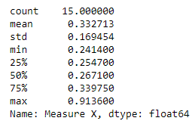

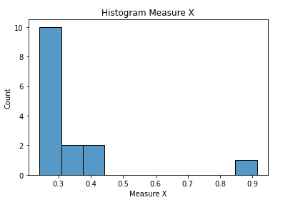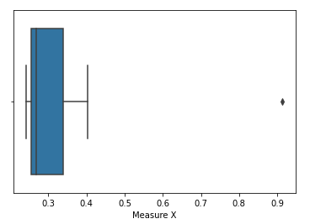

Outlier: Morgan Stanley is Outlier



Answer the following three questions based on the box-plot above.

1. What is inter-quartile range of this dataset? (please approximate the numbers) In one line, explain what this value implies.

Answer:

IQR = 12-5=7(50% of data in this range)

1. What can we say about the skewness of this dataset?

Answer:

The Dataset is positively skewed

1. If it was found that the data point with the value 25 is actually 2.5, how would the new box-plot be affected?

Answer:

If value 25 is 2.5 then there is no outlier in boxplot all datapoints are in fence will be 0 to

19 in boxplot



Answer the following three questions based on the histogram above.

1. Where would the mode of this dataset lie?

Answer:

Mode lies in between 4 to 8

1. Comment on the skewness of the dataset.

Answer:

Dataset is positively skewed

1. Suppose that the above histogram and the box-plot in question 2 are plotted for the same dataset. Explain how these graphs complement each other in providing information about any dataset.

Answer:

Histogram gives idea about frequency so from this histrogram mode of dataset is 4, 25 is outlier and median of the dataset is 7

1. AT&T was running commercials in 1990 aimed at luring back customers who had switched to one of the other long-distance phone service providers. One such commercial shows a businessman trying to reach Phoenix and mistakenly getting Fiji, where a half-naked native on a beach responds incomprehensibly in Polynesian. When asked about this advertisement, AT&T admitted that the portrayed incident did not actually take place but added that this was an enactment of something that “could happen.” Suppose that one in 200 long-distance telephone calls is misdirected. What is the probability that at least one in five attempted telephone calls reaches the wrong number? (Assume independence of attempts.)

Answer:

No. of calls = n = 5

p = 1/200, q = 199/200

p(x)=nCx px qn-x

p(x)=0.024

1. Returns on a certain business venture, to the nearest $1,000, are known to follow the following probability distribution

|  |  |
| --- | --- |
| x | P(x) |
| -2,000 | 0.1 |
| -1,000 | 0.1 |
| 0 | 0.2 |
| 1000 | 0.2 |
| 2000 | 0.3 |
| 3000 | 0.1 |

1. What is the most likely monetary outcome of the business venture?

Answer:

Probability p = 0.3 return is $2000

1. Is the venture likely to be successful? Explain

Answer:

0.2+0.2+0.1=60% probability of venture likely to be successful

1. What is the long-term average earning of business ventures of this kind? Explain

Answer:

E(x) = X.P(X)

(-2000 X 0.1) = -200

(-1000 X 0.1) = -100

(0 X 0.2 ) = 0

(1000 X 0.2) = 200

(2000 X 0.3) = 600

(3000 X 0.1) = 300

-200-100+200+600+300=$800

Average Earning = $ 800

1. What is the good measure of the risk involved in a venture of this kind? Compute this measure

Answer:

P(loss) = p(x=-2000)+p(x=-1000)

= 0.1+0.1

=0.2

i.e there is 20 % risk involved in a venture of this kind